Proposal to restore native forest to Perkins Farm

Background
NZTA has agreed to purchase Perkins Farm and settlement is likely to be in 2013
NZTA will consider proposals for the use of the land in the near future.
Nga Uruora (NUKP) is a conservation trust in Paekakariki that has been restoring native forest to the escarpment between Paekakariki and Pukerua Bay since 1997.
NUKP has the know-how and experience to manage restoration projects.

NUKP’s Vision
For many years Nga Uruora’s grand vision has been to restore native forest running all the way from Porirua to Waikanae and bring back native birds, to eliminate animal pests and exotic weeds, and to encourage greater biodiversity in native wildlife.

We believe the same vision should be adopted for Perkins Farm.

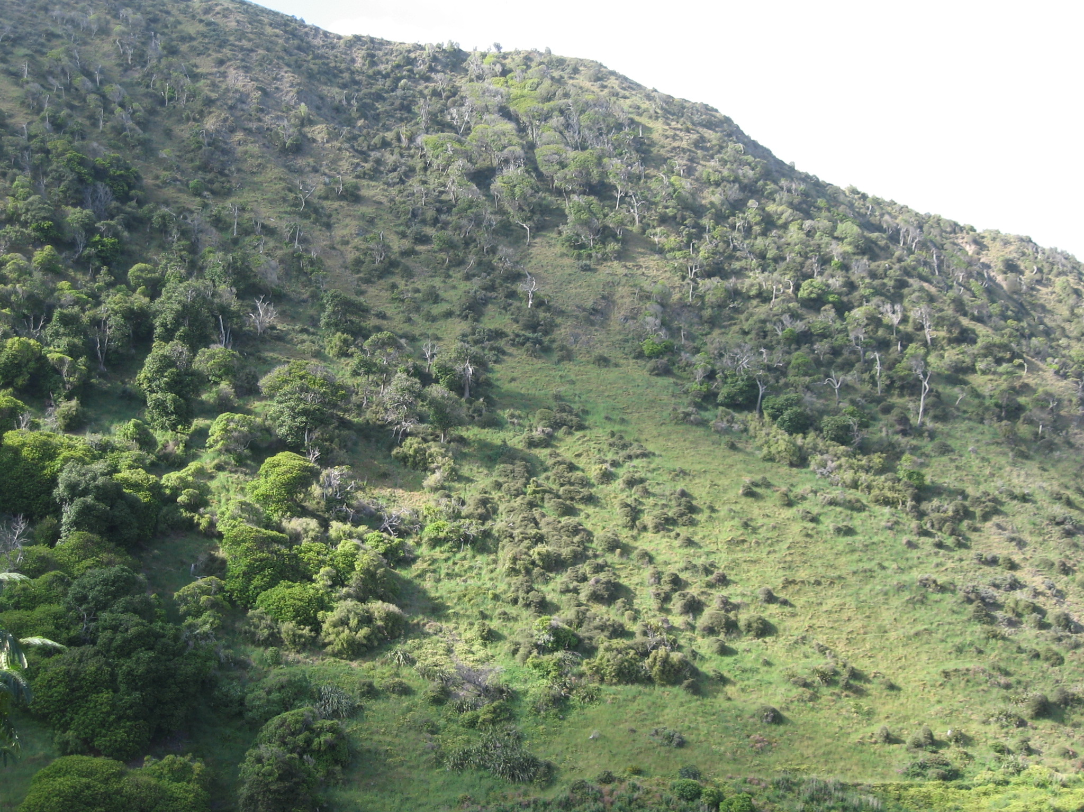

Paekakariki Station Escarpment, remnants of native bush with invasions of boxthorn, broom, wattle and pampas.

So we imagine the steep Station Escarpment being cleared of unsightly weeds such as wattle and boxthorn, and converted to a varied contrasting patchwork of native trees attractive to travellers by rail or road and to residents of Paekakariki. The valleys including Waikakariki and Hairpin Gully, would initially be filled with a dense mixture of kanuka, manuka and flax, progressing to taller native trees as the forest matures. The forest would cover the hillsides up to the ridge tops where there would be open spaces for views and a mixture of native shrubs and shorter native trees.
The forest would be filled with the sounds of native birds. There would be paths along the ridges creating wonderful walks with views out over the sea to Kapiti and the South Island. It would become a magnet for recreational activities. For too long our local hills have been reserved for sheep. Now is the chance to create a space that the public can enjoy.

NUKP’s Restoration Philosophy
Nga Uruora’s philosophy is to rely on natural regeneration of native forest. This is the most practical approach on steep coastal hill country. It is a slow process by conventional standards but has been achieved successfully on inland hills in the Wellington Region, for example on the Eastern Hutt Hills where native bush now stands where gorse covered the hillsides not long ago.
The first step is to remove animal pests by trapping possums, stoats, rats and other rodents. The area should be retired from sheep farming and fenced off to keep stray animals out (with the possible exception of the first few years when sheep grazing may be continued –see below). A continuous trapping program with monitoring is started.
The next step is to remove invasive exotic weeds which have the potential to spread over wide areas. This is done by a combination of cutting and stump treatment and spraying herbicides. Generally weed removal is an ongoing process throughout the life of the project.
Establishing a ground cover, usually low growing shrubs, follows. This provides the shelter for later plantings of taller shrubs and trees. There are two approaches:
- Allow sheep grazing to continue and encourage the spread of tauhinu and Coprosma propinqua by sowing seed over wide areas and planting clumps to provide sources of seed. These two species are among the few able to germinate and grow in the presence of sheep.

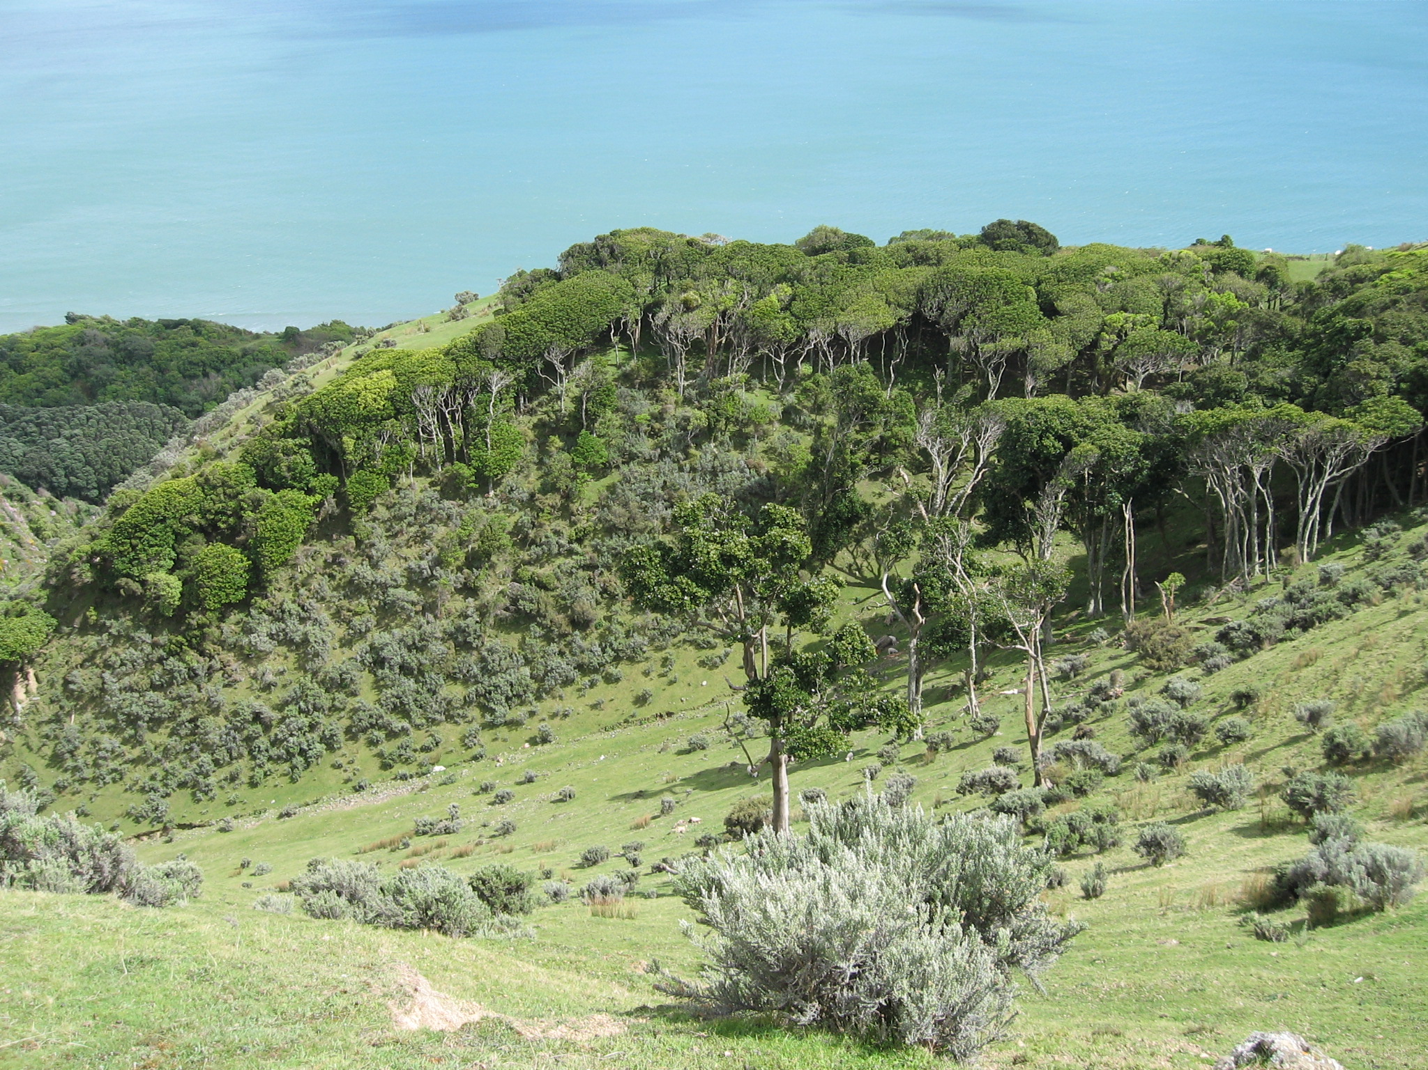

Tauhinu spreading on grazed farmland in Hairpin Gully. Removing sheep from this gully would allow native trees to grow through the tauhinu.

- Remove sheep and allow natural regeneration in the presence of rank grass. Grass prevents germination and growth of most species with the exception of Muelenbeckia complexa which grows over the grass and gradually kills it and forms a thick cushion sometimes up to 1 metre thick. Other native species will germinate and grow where the soil is disturbed eg at the edge of slips, or at the edges of existing patches of bush. Eventually Meulenbeckia will allow native shrubs and trees to grow through.
A parallel approach is to plant clumps or nodes consisting of a mix of species to provide sources of seed which will be spread by birds or wind. We refer to this as strategic planting. These plantings would be placed so as to take advantage of wind and bird movements, and may need protecting against sheep or rabbits.
With natural regeneration maintenance work such as releasing is kept to a minimum. Monitoring of progress by means of photography and bird counts is important to provide intelligence on what processes are working best.

The steep areas of Perkins Farm fall into 3 categories:
- Steep coastal escarpment which runs from Transmission Gully south to Paekakariki Hill Road.
- Valleys such as Waikakariki (Fly-by-Wire), Hairpin – includes stream beds, and steep sides and heads of valleys.
- Ridge tops

Steep Coastal Escarpment
The steep slopes of the escarpment are seen by everybody travelling by road and rail and also are viewed all the time by residents of Paekakariki. This area should become an attractive mix of low native shrubs and trees perhaps with the occasional flowering tree such as kowhai. The vegetation cover will stabilise the slopes.
At present the slopes are badly infested with boxthorn and wattle. Exotic broom and pampas grass are becoming established and will spread rapidly if not controlled. The first step would be to tackle the pampas and broom, followed by wattle and boxthorn. Several years of painstaking work would be needed.
Existing patches of native bush consisting of mahoe, karaka, kohekohe, etc have been in existence for many years as proved by old photographs. There are also patches of kanuka. Neither show much sign of spreading probably due to competition from rank grass. On the other hand Coprosma propinqua has spread considerably in the last 100 years, and it provides good stabilisation of scree slopes.
It is important to plant areas which have been cleared of weeds to prevent reinfestation. We would therefore plant the hardiest of species to withstand the exposure and dry conditions – we suggest tauhinu, propinqua, mountain flax and cabbage trees. We could also trial manual spreading of seed, especially tauhinu and propinqua seed.

Valleys such as Waikakariki
In the stream beds we would sow seeds of Phormium tenax, and probably plant as well. The tough flax will provide filtering of the water, will hold back silt and stones and slow the runoff.
On the stream sides we would make strategic plantings of species likely to grow and provide ground cover in the damp conditions where the water table is near the surface eg hebes, mountain flax, mahoe, ngaio, etc. These species would be sources of seed which would soon be spread along the streams by wind or birds.
On the hillsides above we would plant clumps of species adapted to drier conditions such as kanuka, manuka, akeake, etc. These clumps would be widely spaced out to reduce investment costs, but would act as seed sources.
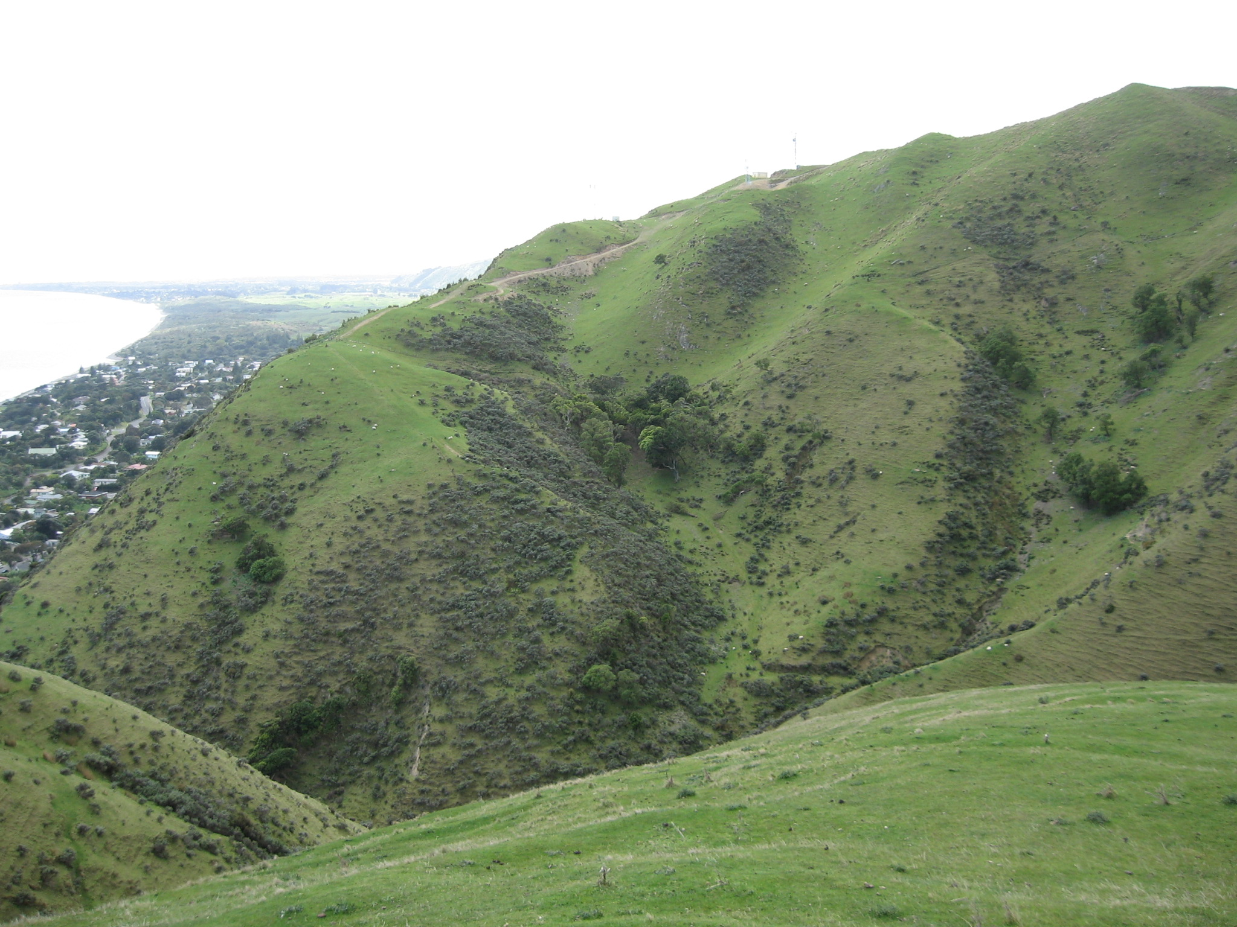

Southern facing slopes of Waikakariki Gully. Note small remnants of native bush which are seed sources and will eventually expand if sheep are removed

Ridge tops
We suggest a mix of open spaces and patches of native bush, say about one-third open space. With walking tracks along the ridges, this would be an attractive mix with views framed by cabbage trees, mountain flax and other good-looking native species. The ridge tops are dry and windy, so only hardy species would be planted such as cabbage trees, flax, kanuka, manuka, akeake and akiraho. Again plantings would be strategic ie in clumps so that the wind and birds spread the seed.

Ken Fraser
Nga Uruora
November 2012

